**Postman usage and Configuration**

Download postman at <https://www.getpostman.com/apps>

select for windows

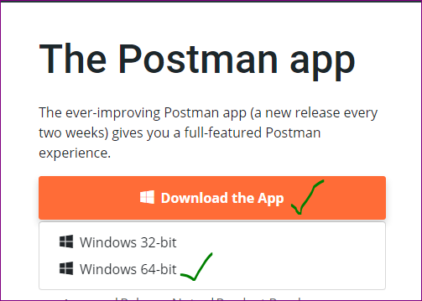

Once downloaded, sign up for it if you don't have an account (with valid e-mail id).

Once done with the Signup process, open postman app in your desktop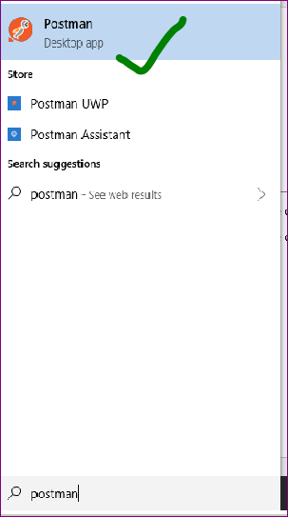

Copy the below file and paste it in your Desktop /any location



Click on **Import**

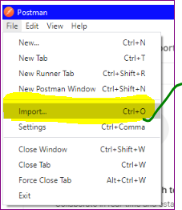

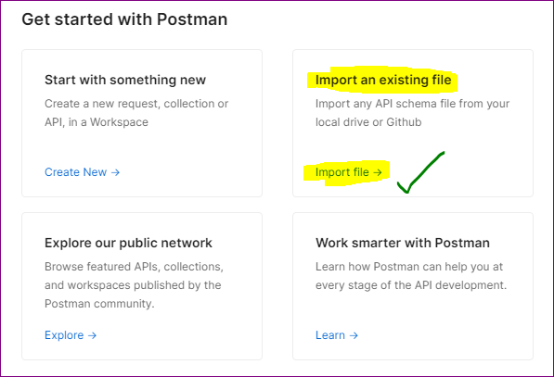

Then click on **Import File** and Click on **Upload Files**

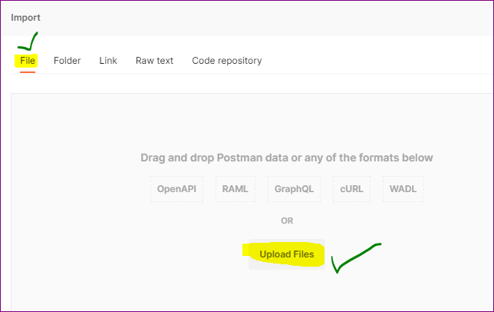

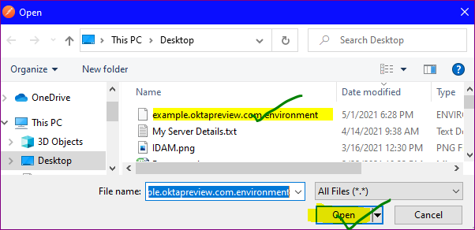

Click on **Import**

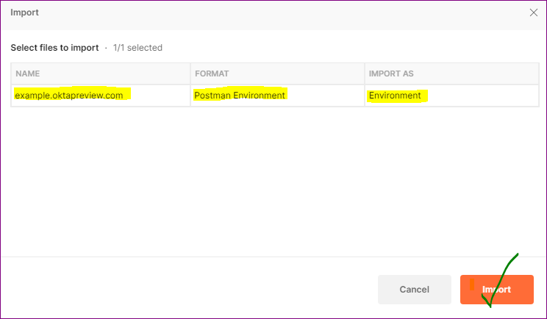

Then Navigate to Environments section and select **example.oktapreview.com**

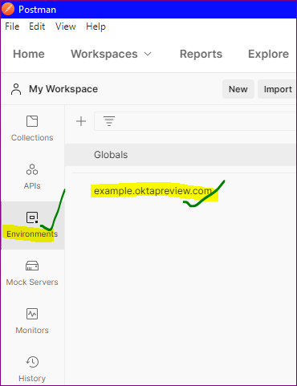

Click on Pencil to change the environment name (As your wish)

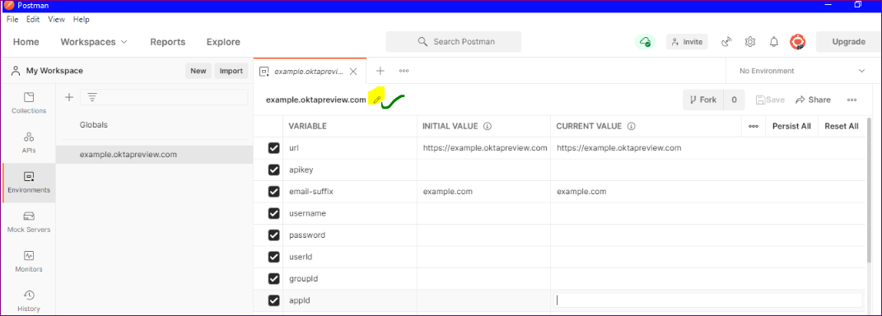

E.g. :- Okta Test Environment (as below)

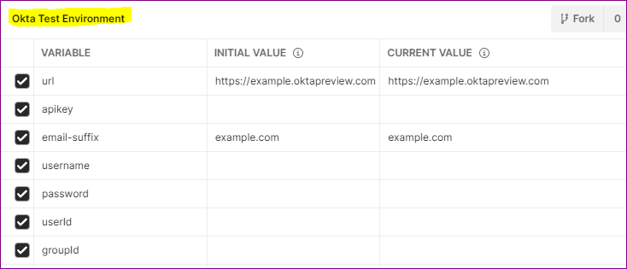

Modify **url** VARIABLE values in INITIAL VALUE and CURRENT VALUE sections with your Okta tenant URL

provide **apikey** value which you generated from Okta tenant (Security >> API >> Create API Token)

Remove **email_suffix** values (example.com) and **appName** Values (amazon_aws)

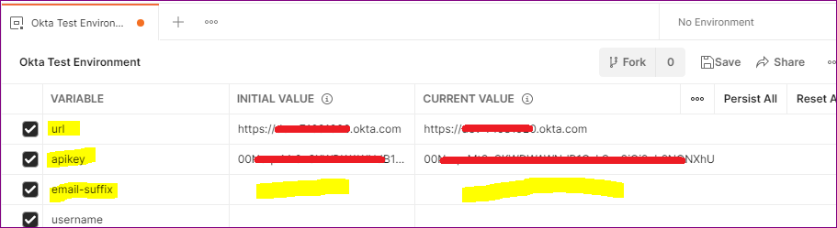



Then Click on Save (Top Right Corner)

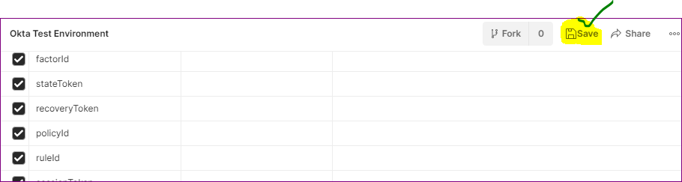

Navigate to Collections section in your postman (No Okta Collections are available at this time which is expected)

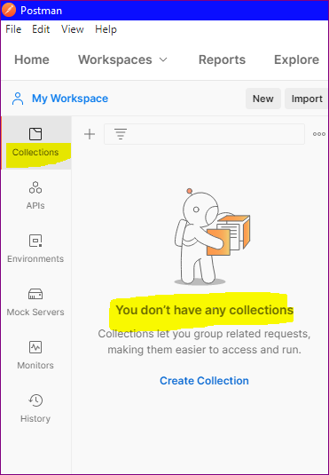

Hit below URL and click on Run in Postman of each collection

https://developer.okta.com/docs/reference/postman-collections/

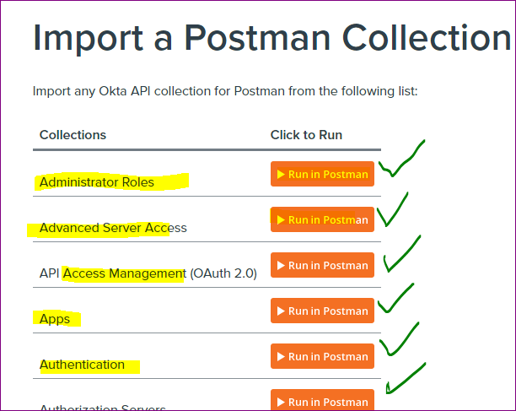

it will open new tab in your browser, select Postman for Windows

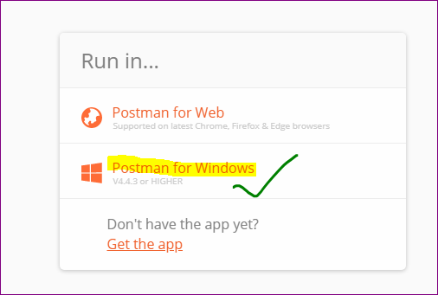

Click on Import

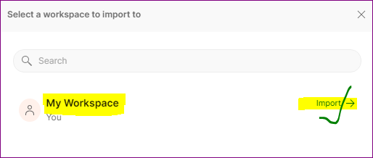

**Repeat the same steps for each collection**

Once collections are imported it looks like as below.

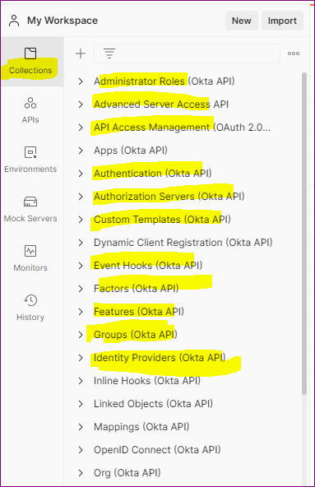

Test Postman by performing any operation

E.g. : **Lifecycle Operations** API, and select **Deactivate User** method to deactivate the user in Okta.

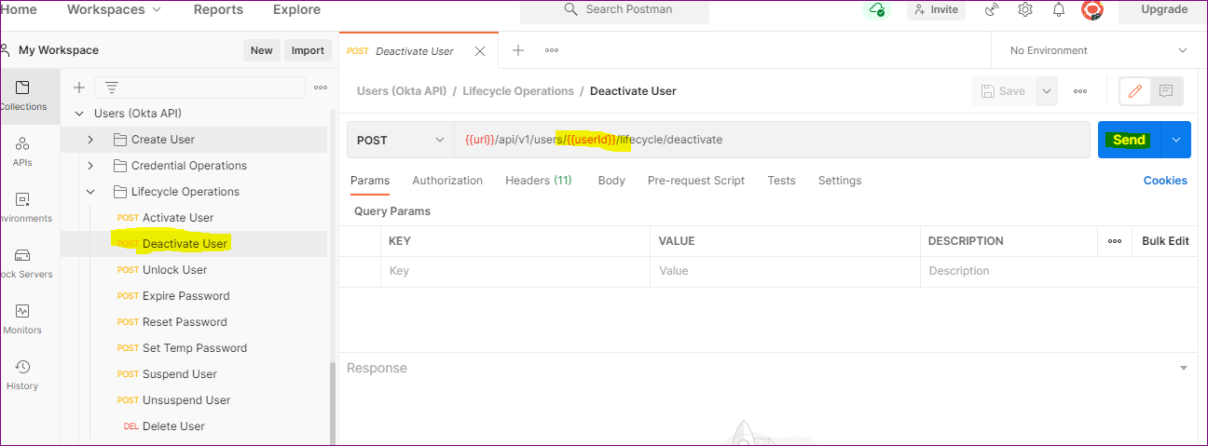

Replace userid variable with constant value (immutable ID of the user) and click on **Send** (make sure your environment is selected (Top Right Corner))

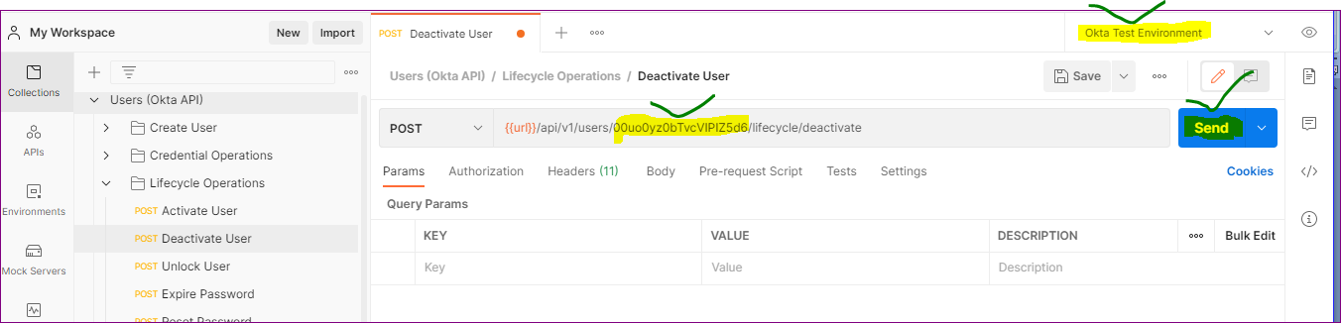

Once request is completed we can see **200 OK** success message and check user status in Okta.

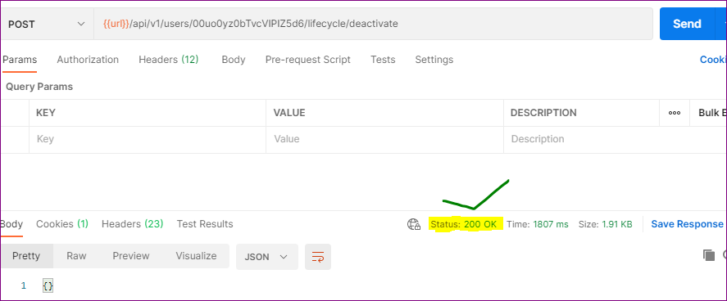

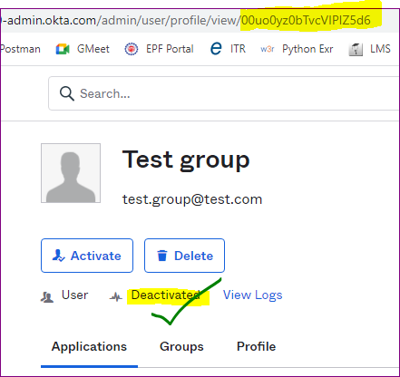

You made it !!

---------------------------------------------------------------- The End------------------------------------------------------------